**Part-1**

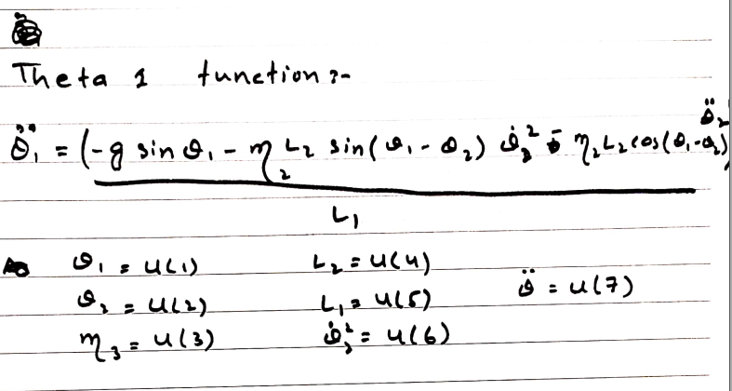

$θ_{1}$**function**

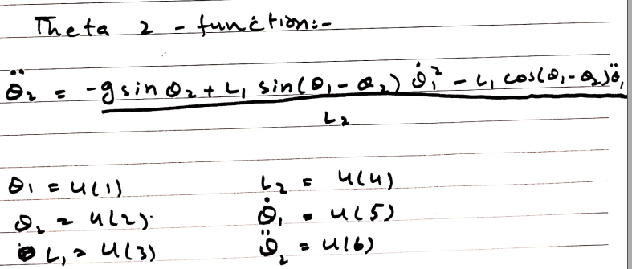

$θ_{2}$**function**

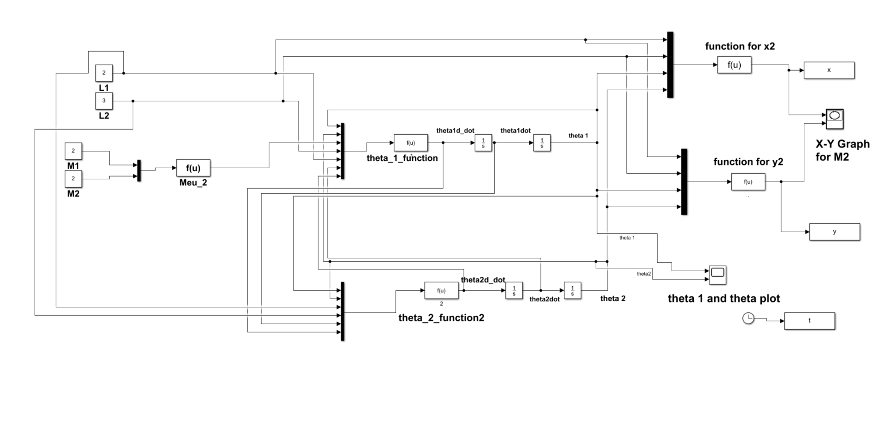**Simulink design**

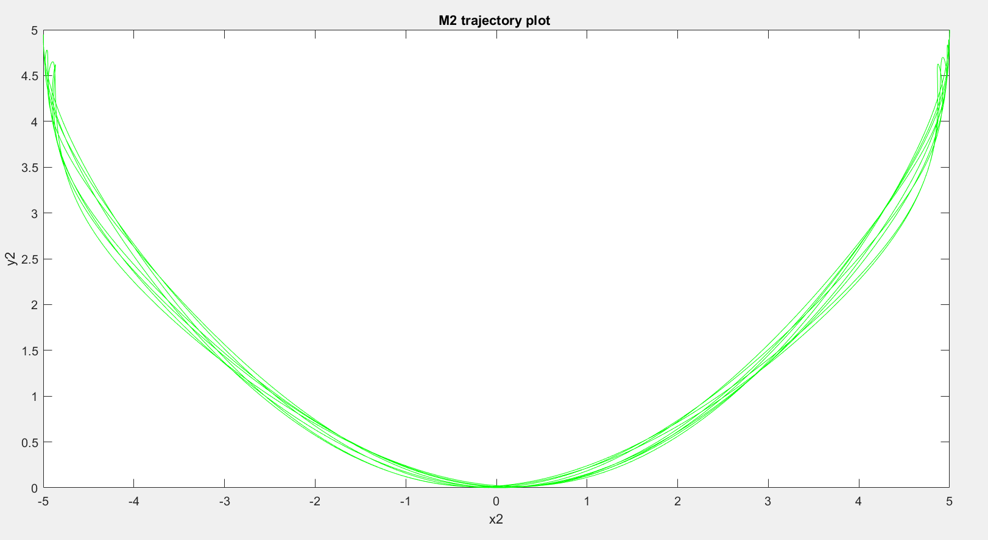

**Show** m2 **trajectory plot (**X2,Y2**) with time**

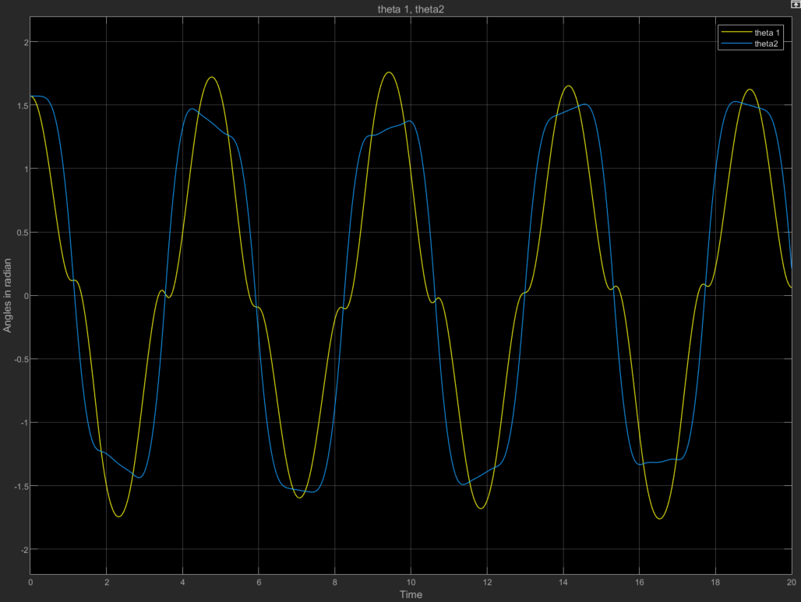

$θ_{1} and θ_{2}$**plots with time on one figure**

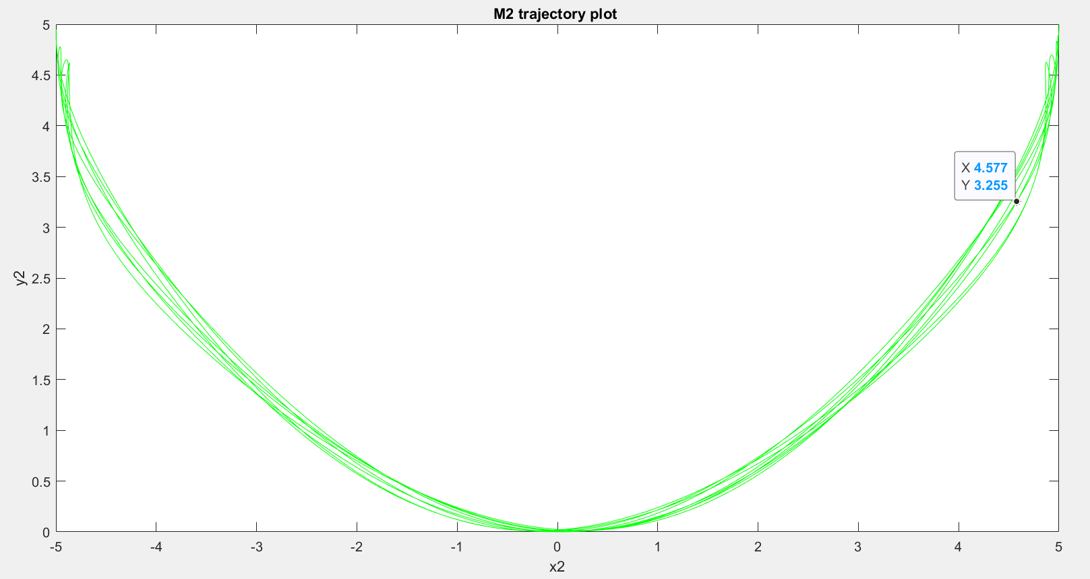

**display** m2 **location (**X2,Y2**) after 10 seconds**

**Read me:**

1. Go to part 1 and open **model_part1** and **code_for_point_t_10**
2. Run **model_part1**
3. Get plot of trajectory of M2 from **XY graph for M2** in Simulink model
4. Get plot of $θ_{1}$ and $θ_{2}$ from **theta 1 and theta2 plot** in Simulink model
5. Run **code_for_point_t_10**  to get the position of M2 after 10 sec

**Part-2**

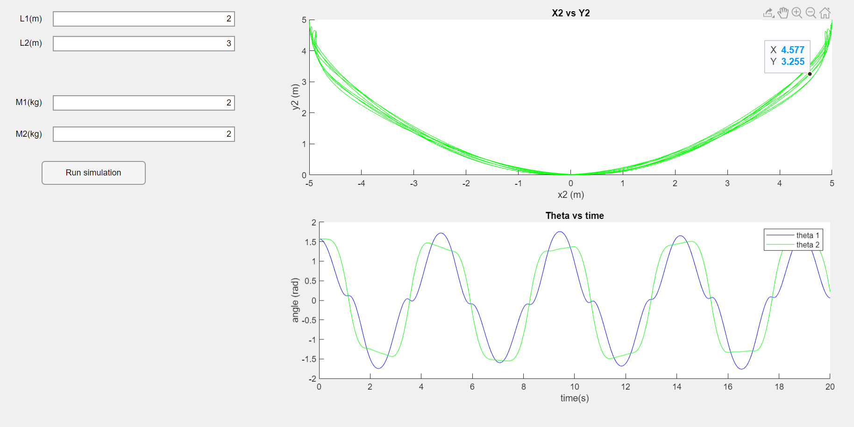

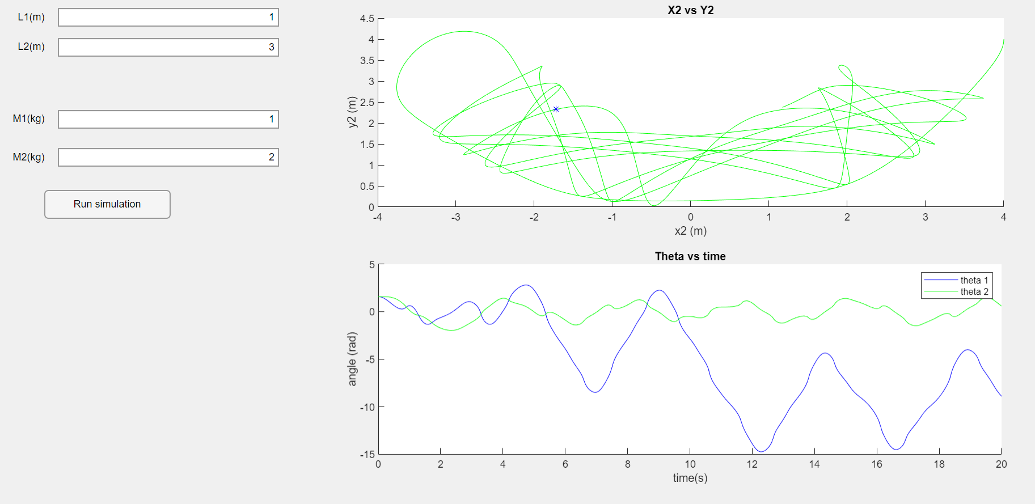

Here is the app for trajectory of second mass.

The **star** show the position of **M2** after 10 second **x2 vs y2 plot**.

**Read me:**

1. Go to part2 and open **app1.mlapp**
2. Run **app1.mlapp**
3. Enter the value of l1, l2 m1 and m2
4. Run simulation